Optical Fiber Communication(OFC)
Semester- 5th
Electronics and Communication Engg.

Introduction
Optical Fiber Communication
OFC is a process of transmitting information from one place to another by sending pulses of light through an optical fiber. The light forms an electromagnetic carrier wave that is modulated to carry information. Fiber is preferred over electrical cabling when high bandwidth, long distance, or immunity to electromagnetic interference are required.
For gigabits and beyond gigabits transmission of data, the fiber optic communication is the ideal choice. This type of communication is used to transmit voice, video, telemetry and data over long distances and local area networks or computer networks. A fiber Optic Communication System uses light wave technology to transmit the data over a fiber by changing electronic signals into light.
Advantages of fiber optics for communications
There are a number of compelling reasons that lead to the widespread adoption of fibre optic cabling for telecommunications applications:
- Fiber optic cables are much lighter than the coaxial cables that might otherwise be used.
- Much lower levels of signal attenuation
- Fiber optic cabling provides a much higher bandwidth allowing more data to be delivered
- Fiber optics do not suffer from stray interference pickup that occurs with coaxial cabling
Applications of fiber optics:-
Fiber optic cables find many uses in a wide variety of industries and applications. Some uses of fiber optic cables include:
- Industrial/Commercial: Used for imaging in hard to reach areas, as wiring where EMI is an issue, as sensory devices to make temperature, pressure and other measurements, and as wiring in automobiles and in industrial settings
- Broadcast/CATV: Broadcast/cable companies are using fiber optic cables for wiring CATV, HDTV, internet, video on-demand and other applications
- Defense/Government: Used as hydrophones for seismic waves and SONAR , as wiring in aircraft, submarines and other vehicles and also for field networking
- Medical: Used as light guides, imaging tools and also as lasers for surgeries
- Data Storage: Used for data transmission
- Telecommunication :Fiber is laid and used for transmitting and receiving purposes
- Networking: Used to connect users and servers in a variety of network settings and help increase the speed and accuracy of data transmission
Working of Optical Fiber Communication System:-
Optical fiber system consists of:-
- Information Source
- Electrical transmit
- Optical Source
- Optical Fiber Cable as channel
- Optical Detector
- Electrical Receive
- Destination
The source provides information in the form of electrical signal to the transmitter. The electrical stage of the transmitter drives an optical source to produce modulated light wave carrier. Semiconductors are usually used as optical source here. The information carrying light wave then passes through the transmission medium i.e. optical fiber cables in this system. it reaches to the receiver stage where the optical detector demodulates the optical carrier and gives an electrical output signal to the electrical stage. The common types of optical detectors used are photo diodes (p-i-n, avalanche), photo-transistors, photo-conductors etc. Finally the electrical stage gets the real information back and gives it to the concerned destination.
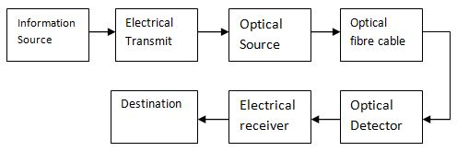
Optical Fiber Communication System Block Diagram
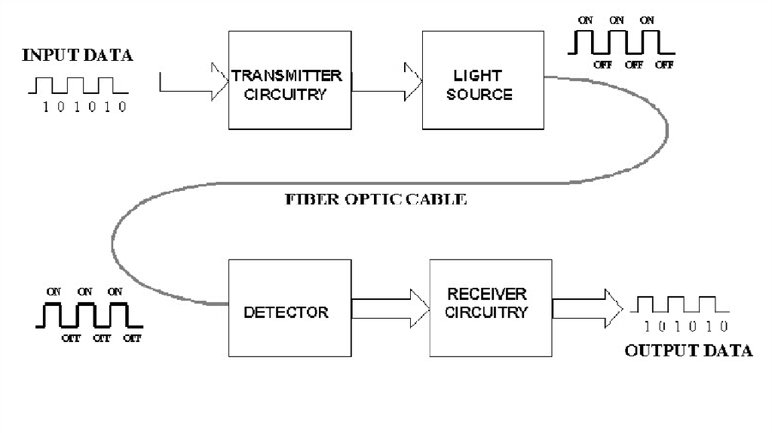
Transmitter section :
The main parts of the transmitter section are a source (either a LED or a LASER), efficient coupling means to couple the output power to the fiber, a modulation circuit and a level controller for LASERs. In present days, for longer repeater spacing, the use of single mode fibers and LASERs are seeming to be essential whereas the earlier transmitters operated within 0.8um to 0.9um wavelength range, used double hetero structure LASER or LED as optical sources. High coupling losses result from direct coupling of the source to optical fibers. 'or LASERs, there are two types of lenses being used for this purpose namely discrete lenses and integral lenses.
Optical Fiber Structure:-
A Fiber Optic Cable consists of four parts.
- Core
- Cladding
- Buffer
- Jacket
- Core
- The core of a fiber cable is a cylinder of plastic that runs all along the fiber cable’s length, and offers protection by cladding. The diameter of the core depends on the application used. Due to internal reflection, the light travelling within the core reflects from the core, the cladding boundary. The core cross section needs to be a circular one for most of the applications.
- Cladding
- Cladding is an outer optical material that protects the core. The main function of the cladding is that it reflects the light back into the core. When light enters through the core (dense material) into the cladding(less dense material), it changes its angle, and then reflects back to the core.
- Buffer
- The main function of the buffer is to protect the fiber from damage and thousands of optical fibers arranged in hundreds of optical cables. These bundles are protected by the cable’s outer covering that is called jacket.
- JACKET
Fiber optic cable’s jackets are available in different colors that can easily make us recognize the exact color of the cable we are dealing with. The color yellow clearly signifies a single mode cable, and orange color indicates multimode.
How Does an Optical Fiber Transmit Light?:-
Light travels down a fiber-optic cable by bouncing repeatedly off the walls. Each tiny photon (particle of light) bounces down the pipe like a bobsleigh going down an ice run. Now you might expect a beam of light, traveling in a clear glass pipe, simply to leak out of the edges. But if light hits glass at a really shallow angle (less than 42 degrees), it reflects back in again—as though the glass were really a mirror. This phenomenon is called total internal reflection. It's one of the things that keeps light inside the pipe.
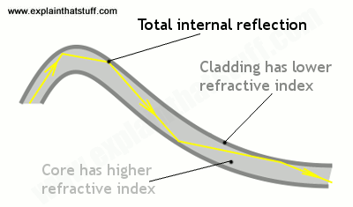
The other thing that keeps light in the pipe is the structure of the cable, which is made up of two separate parts. The main part of the cable—in the middle—is called the core and that's the bit the light travels through. Wrapped around the outside of the core is another layer of glass called the cladding. The cladding's job is to keep the light signals inside the core. It can do this because it is made of a different type of glass to the core. (More technically, the cladding has a lower refractive index.)
Suppose you want to shine a flashlight beam down a long, straight hallway. Just point the beam straight down the hallway -- light travels in straight lines, so it is no problem. What if the hallway has a bend in it? You could place a mirror at the bend to reflect the light beam around the corner. What if the hallway is very winding with multiple bends? You might line the walls with mirrors and angle the beam so that it bounces from side-to-side all along the hallway. This is exactly what happens in an optical fiber. Single mode vs Multimode Fibers:-
Single Mode Fiber:-
Single Mode fiber optic cable has a small diametral core that allows only one mode of light to propagate. Because of this, the number of light reflections created as the light passes through the core decreases, lowering attenuation and creating the ability for the signal to travel further. This application is typically used in long distance, higher bandwidth runs by Telcos, CATV companies, and Colleges and Universities.
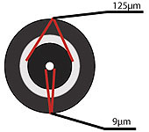
Single Mode fiber is usually 9/125 in construction. This means that the core to cladding diameter ratio is 9 microns to 125 microns.
Multimode Fiber Optic Cable
fiber-optic-cable-internal-structure: Multimode fiber optic cable has a large diametral core that allows multiple modes of light to propagate. Because of this, the number of light reflections created as the light passes through the core increases, creating the ability for more data to pass through at a given time. Because of the high dispersion and attenuation rate with this type of fiber, the quality of the signal is reduced over long distances. This application is typically used for short distance, data and audio/video applications in LANs. RF broadband signals, such as what cable companies commonly use, cannot be transmitted over multimode fiber.
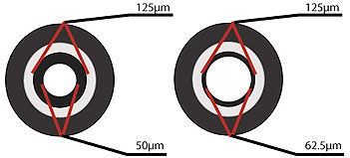
Multimode fiber is usually 50/125 and 62.5/125 in construction. This means that the core to cladding diameter ratio is 50 microns to 125 microns and 62.5
microns to 125 microns.
Multimode fibers are of two types:-
1. Step Index Multimode Fiber
2. Graded Index Multimode Fiber

Step-Index Multimode Fiber
Due to its large core, some of the light rays that make up the digital pulse may travel a direct route, whereas others zigzag as they bounce off the cladding. These alternate paths cause the different groups of light rays, referred to as modes, to arrive separately at the receiving point. The pulse, an aggregate of different modes, begins to spread out, losing its well-defined shape. The need to leave spacing between pulses to prevent overlapping limits the amount of information that can be sent. This type of fiber is best suited for transmission over short distances.
Graded-Index Multimode Fiber
It Contains a core in which the refractive index diminishes gradually from the center axis out toward the cladding. The higher refractive index at the center
makes the light rays moving down the axis advance more slowly than those near the cladding. Due to the graded index, light in the core curves helically rather than zigzag off the cladding, reducing its travel distance. The shortened path and the higher speed allow light at the periphery to arrive at a receiver at about the same time as the slow but straight rays in the core axis. The result: digital pulse suffers less dispersion. This type of fiber is best suited for local-area networks.
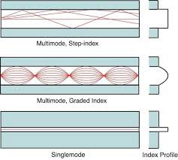
OPTICAL FIBER LOSS AND ATTENUATION
The attenuation of an optical fiber measures the amount of light lost between input and output. Total attenuation is the sum of all losses.
Optical losses of a fiber are usually expressed in decibels per kilometer (dB/km). The expression is called the fiber’s attenuation coefficient α and the expression is
Decibels Per Kilometer
where P(z) is the optical power at a position z from the origin, P(0) is the power at the origin.
For a given fiber, these losses are wavelength-dependent which is shown in the figure below. The value of the attenuation factor depends greatly on the fiber material and the manufacturing tolerances, but the figure below shows a typical optical fiber’s attenuation spectral distribution.
The typical fused silica glass fibers we use today has a minimum loss at 1550nm.
optical-fiber-attenuation
Optical Fiber Loss Mechanisms
Absorption
Absorption is uniform. The same amount of the same material always absorbs the same fraction of light at the same wavelength. If you have three blocks of the same type of glass, each 1-centimeter thick, all three will absorb the same fraction of the light passing through them.
Absorption also is cumulative, so it depends on the total amount of material the light passes through. If the absorption is 1% per centimeter, it absorbs 1% of the light in the first centimeter, and 1% of the remaining light the next centimeter, and so on.
Intrinsic Material Absorption
Intrinsic absorption is caused by interaction of the propagating lightwave with one more major components of glass that constitute the fiber’s material composition. These looses represent a fundamental minimum to the attainable loss and can be overcome only by changing the fiber material.
An example of such an interaction is the infrared absorption band of SiO2 shown in the above figure. However, in the wavelength regions of interest to optical communication (0.8-0.9um and 1.2-1.5um), infrared absorption tails make negligible contributions.
Extrinsic Impurity Ions Absorption
Extrinsic impurity ions absorption is caused by the presence of minute quantity of metallic ions (such as Fe2+, Cu2+, Cr3+) and the OH– ion from water dissolved in glass.
Impurity Ion Loss due to 1ppm of impurity (dB/km) Absorption Peak Wavelength (um)
Scattering
These losses occur when a wave interacts with a particle in a way that removes energy in the directional propagating wave and transfers it to other directions. The light isn’t absorbed, just sent in another direction. However, the distinction between scattering and absorption doesn’t matter much because the light is lost from the fiber in either case.
There are two main types of scattering: linear scattering and nonlinear scattering.
For linear scattering, the amount of light power that is transferred from a wave is proportional to the power in the wave. It is characterized by having no change in frequency in the scattered wave.
On the other hand, nonlinear scattering is accompanied by a frequency shift of the scattered light. Nonlinear scattering is caused by high values of electric field within the fiber (modest to high amount of optical power). Nonlinear scattering causes significant power to be scattered in the forward, backward, or sideways directions.
Rayleigh scattering (Linear Scattering)
Rayleigh scattering (named after the British physicist Lord Rayleigh) is the main type of linear scattering. It is caused by small-scale (small compared with the wavelength of the lightwave) inhomogeneities that are produced in the fiber fabrication process. Examples of inhomogeneities are glass composition fluctuations (which results in minute refractive index change) and density fluctuations (fundamental and not improvable). Rayleigh scattering accounts for about 96% of attenuation in optical fiber.
As light travels in the core, it interacts with the silica molecules in the core. These elastic collisions between the light wave and the silica molecules result in Rayleigh scattering. If the scattered light maintains an angle that supports forward travel within the core, no attenuation occurs. If the light is scattered at an angle that does not support continued forward travel, the light is diverted out of the core and attenuation occurs. Depending on the incident angle, some portion of the light propagates forward and the other part deviates out of the propagation path and escapes from the fiber core. Some scattered light is reflected back toward the light source. This is a property that is used in an OTDR (Optical Time Domain Reflectometer) to test fibers.
Mie Scattering (Linear Scattering)
Mie scattering is named after German physicist Gustav Mie. This theory describes scattering of electromagnetic radiation by particles that are comparable in size to a wavelength (larger than 10% of wavelength).
For particles much larger, and much smaller than the wavelength of scattered light there are simple and excellent approximations that suffice.
For glass fibers, Mie scattering occurs in inhomogeneities such as core-cladding refractive index variations over the length of the fiber, impurities at the core-cladding interface, strains or bubbles in the fiber, or diameter fluctuations.
Mie scattering can be reduced by carefully removing imperfections from the glass material, carefully controlling the quality and cleanliness of the manufacturing process.
In commercial fibers, the effects of Mie scattering are insignificant. Optical fibers are manufactured with very few large defects. (larger than 10% of wavelength)
Here is an interactive Mie Scattering calculator on the web developed by Scott Prahl.
Brillouin Scattering (Nonlinear Scattering)
Brillouin scattering is caused by the nonlinearity of a medium. In glass fibers, Brillouin scattering shows as a modulation of the light by the thermal energy in the material.
Brillouin Scattering
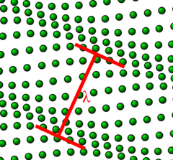
An incident photon can be converted into a scattered photon of slightly lower energy, usually propagating in the backward direction, and a phonon (vibrational energy). This coupling of optical fields and acoustic waves occurs via electrostriction.
The frequency of the reflected beam is slightly lower than that of the incident beam; the frequency difference vB corresponds to the frequency of emitted phonons. This is called Brillouin Frequency Shift. This phenomenon has been
used for fiber optic sensor applications.
Brillouin-Frequency-Shift
Brillouin scattering can occur spontaneously even at low optical powers. This is different than Stimulated Brillouin Scattering which requires optical power to meet a threshold high enough to happen.
Above a certain threshold power, stimulated Brillouin scattering can reflect most of the power of an incident beam. The optical power level at which stimulated Brillouin scattering becomes significant in a single mode fiber is given by the empirical formula below.
Stimulated Brillouin Scattering Power Level Threshold
where
PB = Stimulated Brillouin Scattering Optical Power Level Threshold (watts)
a’ = Fiber radius (um)
λ’ = Light source wavelength (um)
α = Fiber loss (dB/km)
△v’ = Light source linewidth (GHz)
Stimulated Raman Scattering (Nonlinear Scattering)
Stimulated Raman scattering is a nonlinear response of glass fibers to the optical intensity of light. This is caused by vibrations of the crystal (or glass) lattice. Stimulated Raman scattering produces a high-frequency optical phonon, as compared to Brillouin scattering, which produces a low-frequency acoustical phonon, and a scattered photon.
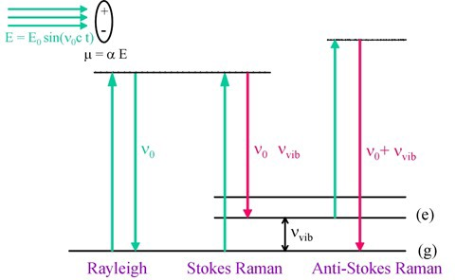
When two laser beams with different wavelengths (and normally with the same polarization direction) propagate together through a Raman-active medium, the longer wavelength beam can experience optical amplification at the expense of the shorter wavelength beam. This phenomenon has been used for Raman amplifiers and Raman lasers.
Raman Scattering
In Stimulated Raman scattering, the scattering is predominately in the forward direction, hence the power is not lost to the receiver.
Stimulated Raman Scattering also requires optical power to be higher than a threshold to happen. The formula below gives the thresholdOptical Power Threshold for Stimulated Raman Scattering
where
PR = Stimulated Raman Scattering Optical Power Level Threshold (watts)
a’ = Fiber radius (um)
λ’ = Light source wavelength (um)
α = Fiber loss (dB/km)
Macrobending Loss
Macrobending happens when the fiber is bent into a large radius of curvature relative to the fiber diameter (large bends). These bends become a great source of power loss when the radius of curvature is less than several centimeters.
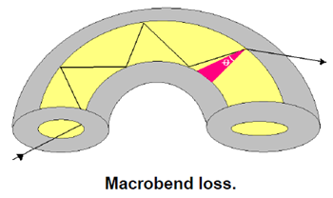
Macrobend may be found in a splice tray or a fiber cable that has been bent.
Macrobend won’t cause significant radiation loss if it has large enough radius.
However, when fibers are bent below a certain radius, radiation causes big light power loss as shown in the figure below.
Macrobend Loss
Corning SMF-28e single mode fibers should not be bent below a radius of 3 inches. 50um graded-index multimode fibers, such as Corning Infinicor 600, should not be bent below a radius of 1.5 inches. 62.5um graded-index multimode fibers, such as Corning Infinicor 300, should be be bend below a radius of 1 inch.
microbending loss
Because external forces are transmitted to the glass fiber through the polymer coating material, the coating material properties and dimensions, as well as external factors, such as temperature and humidity, affect the microbending sensitivity of a fiber.
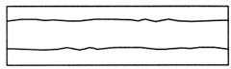
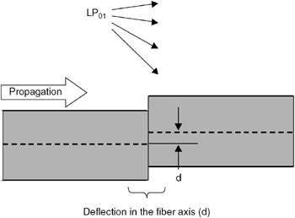
Microbending sensitivity is also affected by coating irregularities such as variations in coating dimensions, the presence of particles such as those in the pigments of color coatings, and inhomogeneities in the properties of the coating materials that vary along the fiber axis.
Interface Inhomogeneities
Interface inhomogeneities can convert high-order modes into lossy modes extending into the cladding where they are removed by the jacket losses.
Impurities trapped at the core-cladding interface or impurities in the fiber buffering can cause these inhomogeneities.
Single mode fibers are more susceptible to losses from geometric irregularities or defects in the jacket material.
However, optical fiber manufacturing technology have improved so much that these interface inhomogeneities now play a insignificant role in fiber losses.
Microbending Loss
Microbendings are the small-scale bends in the core-cladding interface. These are localized bends can develop during deployment of the fiber, or can be due to local mechanical stresses placed on the fiber, such as stresses induced by cabling the fiber or wrapping the fiber on a spool or bobbin.
Microbending can also happen in the fiber manufacturing process. It is sharp but microscopic curvatures that create local axial displacement of a few microns (um)
and spatial wavelength displacement of a few millimeters.
Microbends can cause 1 to 2 dB/km losses in fiber cabling process.
fibermicrobending
The following figure shows the the impact of a single microbend, at which, analogous to a splice, power can be coupled from the fundamental mode into higher order leaky modes.

